Week 5 Screenshot Evidence

Exercise 11

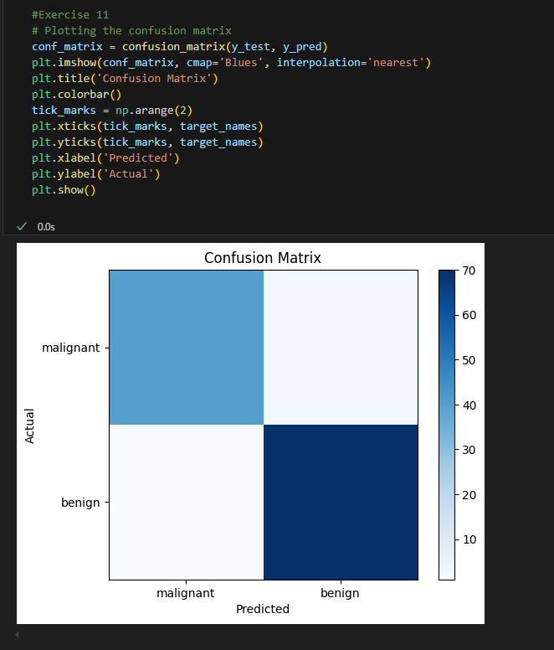

Exercise 12 – I have encountered that I had to make sure that I ran everything to make sure that the output is correct

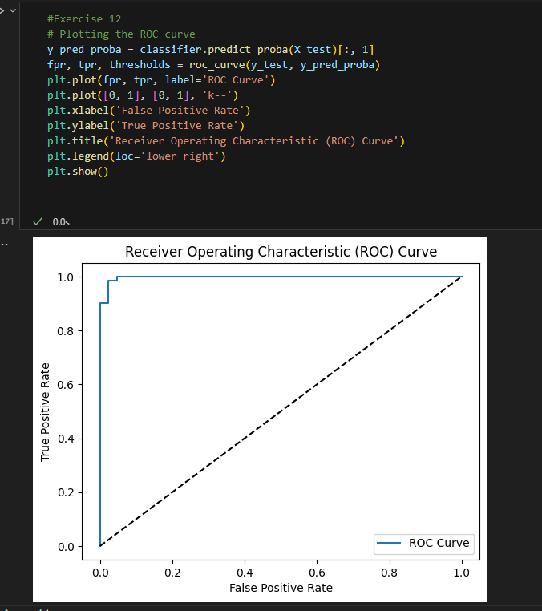

Exercise 14

